**Node1**

**Password** = welcome

**Public address of the key:** 0xd4aF6Be2Af0C062D38F226d7cfa53fd887a3cEeC

**Path of the secret key file**: node1\keystore\UTC--2021-02-16T00-07-27.340028000Z--d4af6be2af0c062d38f226d7cfa53fd887a3ceec

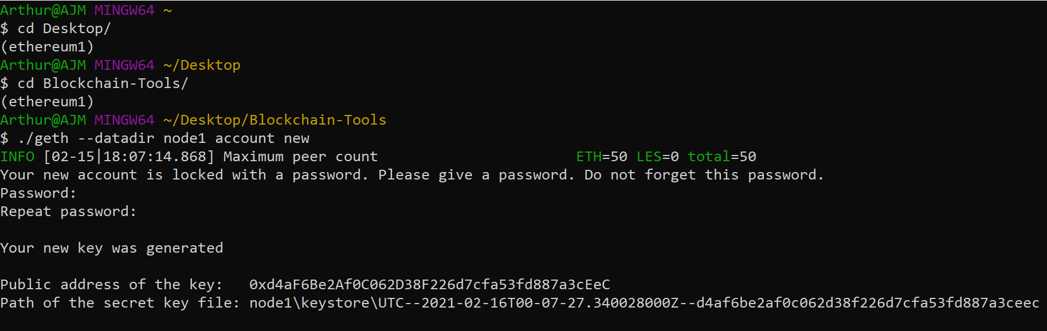

**Node2**

**Password** = welcome1

**Public address of the key:** 0x1727d426973fD037fcB34e90c150C4e84eF2fE9D

**Path of the secret key file:** node2\keystore\UTC--2021-02-16T00-09-45.549929200Z--1727d426973fd037fcb34e90c150c4e84ef2fe9d

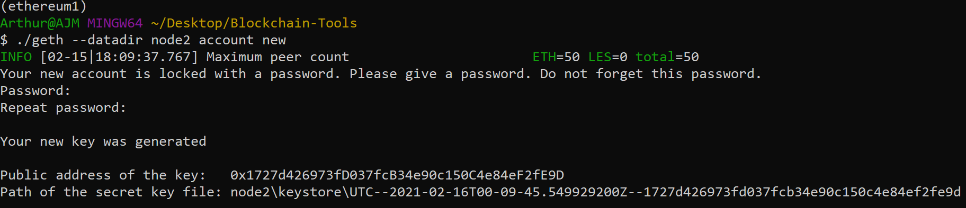

**Genesis Block**

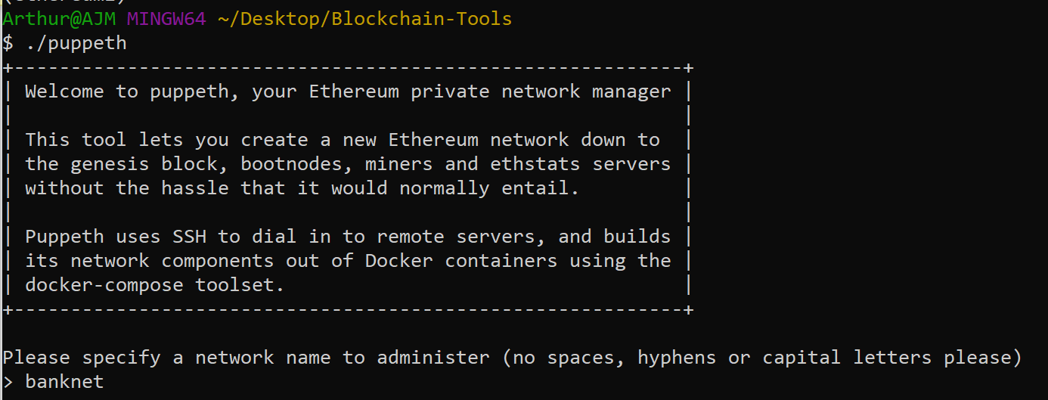

**Network Name** = banknet

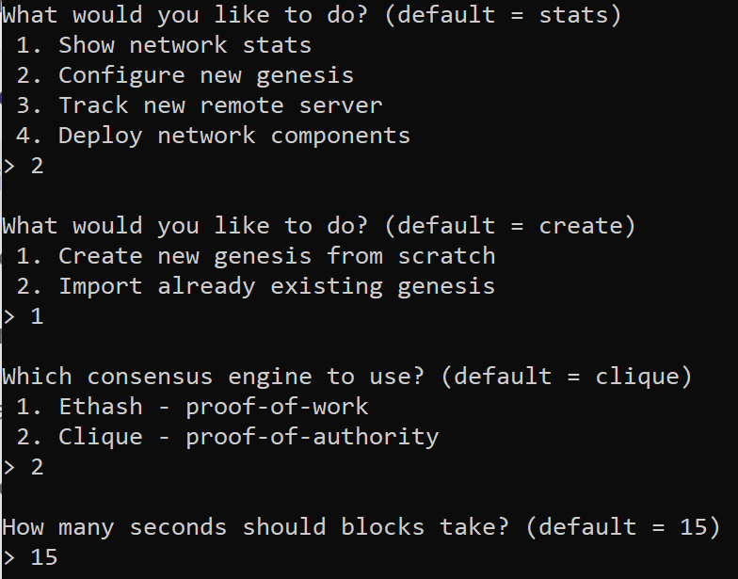

Configure new genesis

Create new genesis from scratch

Clique – proof-of-authority

15 seconds

**Chain/Network ID** = 2333

**Export Genesis:**

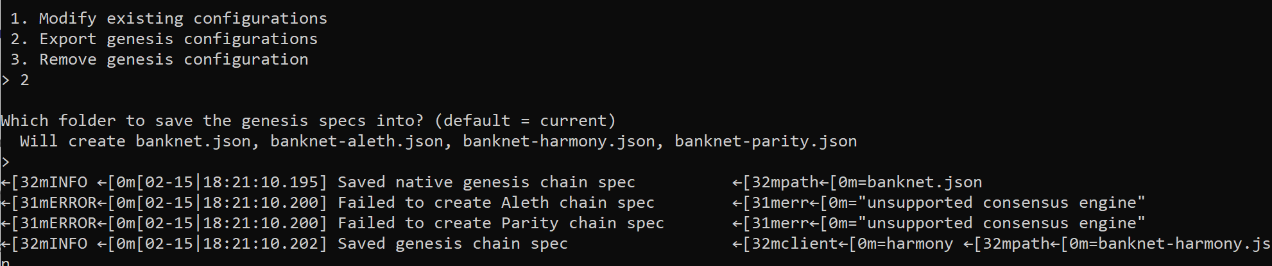

**Initialize each node**

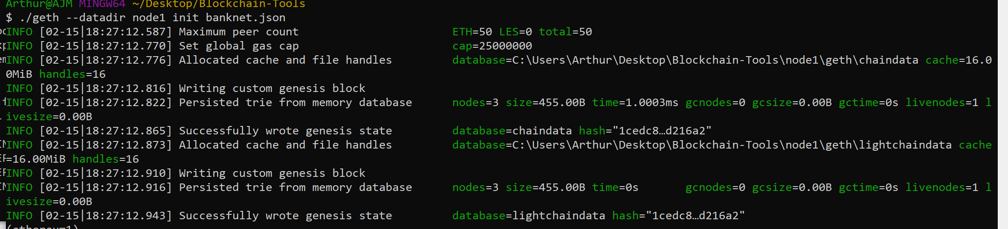

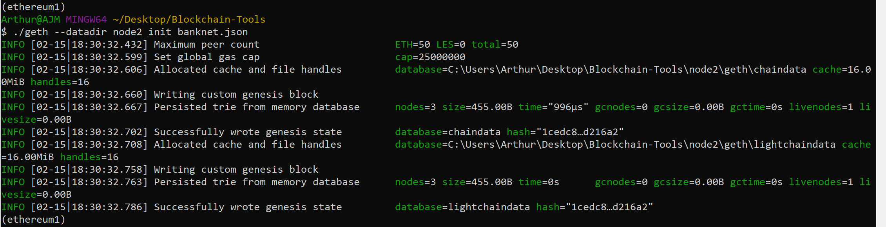

**Run nodes:**

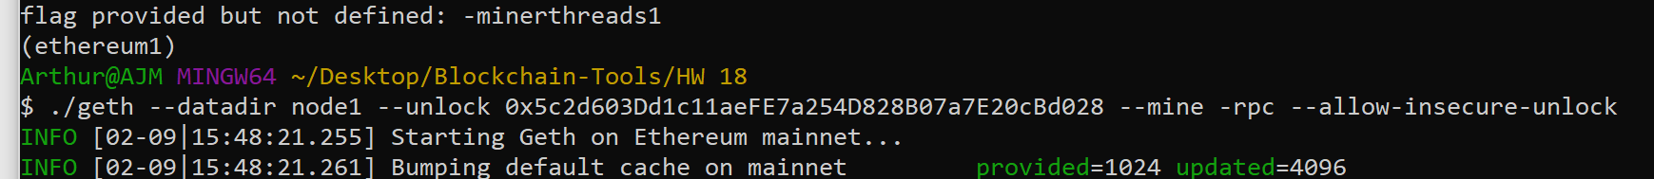

**Enode 1**

enode://875c58676be2478a4d7f3694d847588b38f251b04fce2b746f91ba04031b408e9db1ae9272c95f7c2a6180e337321613740c6941d25f78b2bdc863bac9d45cba@127.0.0.1:30303



Run nodes:

**Node1**

./geth --datadir node1 --unlock "0xd4aF6Be2Af0C062D38F226d7cfa53fd887a3cEeC" --mine --rpc --allow-insecure-unlock --ipcdisable

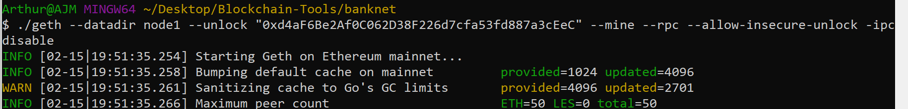

**Node2**

./geth --datadir node2 --unlock “0x1727d426973fD037fcB34e90c150C4e84eF2fE9D” --mine --port 30304 --bootnodes enode://875c58676be2478a4d7f3694d847588b38f251b04fce2b746f91ba04031b408e9db1ae9272c95f7c2a6180e337321613740c6941d25f78b2bdc863bac9d45cba@127.0.0.1:30303 --ipcdisable --allow-insecure-unlock

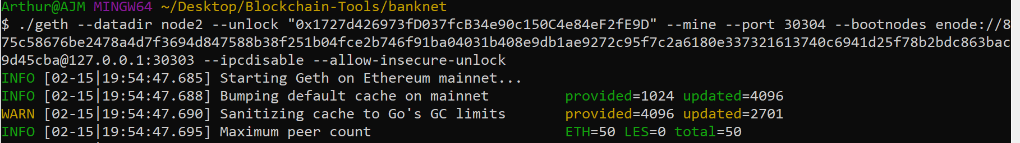

**MyCrypto: Unable to connect to custom network banknet..?**

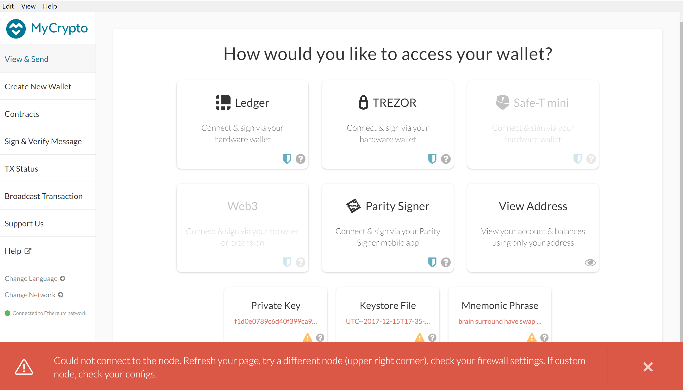

**I did not pass go, I have no money, I go directly to homework 18 jail**

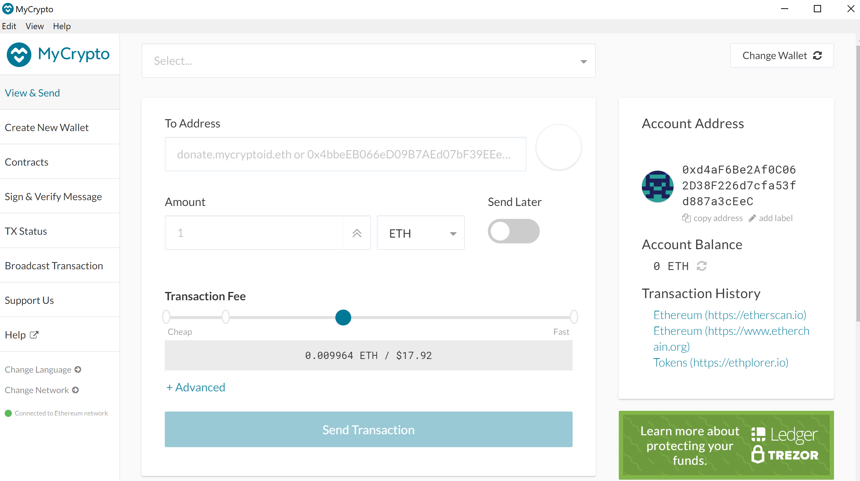

**Custom Node**

Node Name: banknet

Network: custom

Network name: banknet

Currency: ETH

Chain ID: 2333

URL: <https://127.0.0.1:8545/>